Project Design Phase-II
Technology Stack (Architecture & Stack)

Date | 20 February 2026
Team ID | LTVIP2026TMIDS73549
Project Name | Streamlining Ticket Assignment for Efficient Support Operations
Maximum Marks | 4 Marks

Technical Architecture:
Technical Architecture
The ServiceNow Operations Ticket Management System follows a cloud-based architecture where users interact with the system through the ServiceNow web interface. The application processes operational support requests and stores ticket information in the ServiceNow database. Automated workflows created using Flow Designer assign tickets dynamically to appropriate support groups such as L1 and L2 teams. Role-based access control mechanisms ensure secure system access, while cloud infrastructure enables scalable and reliable ticket management operations.
Streamlining Ticket Assignment for Efficient Support Operations

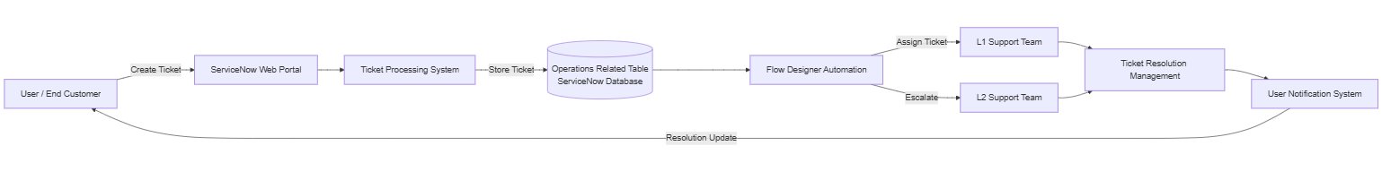

Table-1 : Components & Technologies:
S.No | Component | Description | Technology
1 | User Interface | User interacts through ServiceNow portal | ServiceNow Web Interface
2 | Application Logic-1 | Ticket creation and submission logic | ServiceNow Forms
3 | Application Logic-2 | Automated ticket routing logic | Flow Designer
4 | Application Logic-3 | Role and access management | ACL & Role Management
5 | Database | Stores operational ticket data | ServiceNow Tables
6 | Cloud Database | Cloud-based ticket storage | ServiceNow Cloud Database
7 | File Storage | Stores attachments and records | ServiceNow Attachment Storage
8 | External API-1 | Notification services | ServiceNow Notification Engine
9 | External API-2 | User authentication services | ServiceNow Identity Management
10 | Machine Learning Model | Intelligent workflow automation (optional) | ServiceNow Predictive Intelligence
11 | Infrastructure (Server / Cloud) | Application hosted on cloud platform | ServiceNow Cloud Infrastructure

Table-2: Application Characteristics:
S.No | Characteristics | Description | Technology
1 | Open-Source Frameworks | Platform-based workflow automation system | ServiceNow Platform
2 | Security Implementations | Role-based access and ACL permissions | RBAC, ACL
3 | Scalable Architecture | Cloud platform supports multiple users and requests | ServiceNow Cloud Architecture
4 | Availability | Highly available cloud-hosted system | ServiceNow Managed Cloud
5 | Performance | Automated ticket assignment reduces processing delay | Workflow Automation

